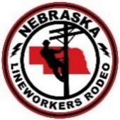
Nebraska Lineworker Rodeo
August 22nd & 23rd, 2020
Sponsorship Opportunities
Nebraska Lineworker Rodeo is seeking sponsors for its Annual Lineworker Rodeo on August 22nd & 23rd, 2020.
As a Sponsor or vendor, you have the opportunity to show your support for the electric utility industry, demonstrate your products and services to Nebraska’s electric-line personnel and network with colleagues.
Benefits  | Champion  Sponsor  (1 allowed) | Platinum  Sponsor | Gold  Sponsor | Silver Sponsor | Bronze Sponsor
 | $3,000 | $2,000 | $1,500 | $1000 | $500
Awards Banquet Sponsor with banner at Banquet & at Registration table | 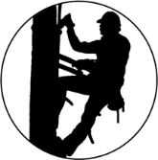
Logo on sleeve shirts
Opportunity to speak during the awards presentation.
Seating at the Banquet | 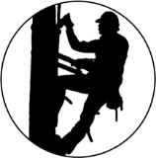
Tickets to the State Fair | 4 TICKETS | 4 TICKETS | 3 TICKETS | 2 TICKETS | 1 TICKET
Competition T-shirts | 4 SHIRTS | 4 SHIRTS | 4 SHIRTS | 2 SHIRTS
Name Listed on Website
Name Listed on Banquet Program |  |  | 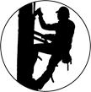

Nebraska Lineworker Rodeo
August 22nd & 23rd, 2020

SPONSORSHIP FORM

Organization/Individual
As you would like it to appear in sponsorship collateral

Mailing/Billing Address

Contact Person Title

Phone Number

Email

Sponsorship Level:

□ Champion Sponsor | | $3,000
□ Platinum Sponsor | | $2,000
□ Gold Sponsor | | $1,500
□ Silver Sponsor | | $1,000
□ Bronze Sponsor  □ Other Donation | | $500  Amount/Value $_______
Extra Banquet Tickets | $20.00___________

I have enclosed $ in a check made payable to Lincoln Electric System or payment by Credit Card at nelinerodeo.com under vendors/registrations. Registration due by August 15, 2020.

Signature Date

Thank you for your support!
Please mail sponsorship form and payment to:
LES-Nebraska Lineworker Rodeo
Terri Dier
2620 Fairfield St.
Lincoln, NE 68521

Questions regarding sponsorship or gift in kind opportunities, please contact Terri Dier at 402-467-7576 or cell phone 402-525-3263

